**SP20: Meeting with Advisor**

Date: 1/30/2020, Starts from 13:00 ~

1. **Research: Authoritarian Welfare State Paper: Write a Note here.**

* **IRCP Presentation scheduled: 26th Feb.**
* **Sample screening; based on ‘e_lexical_index’**
  + If e_lexical_index = 6, democracy otherwise autocracy.
  + If e_lexical_index < 6, then I consider the countries are non-democracy, which means “authoritarian regimes”
* **Dahlum, Knutsen and Wig. 2019. “Who Revolts? Empirically Revisiting the Social Origins of Democracy.” *The Journal of Politics*. 81(4): 1494-1499.**
  + Argument: Movement dominated by industrial workers or middle classes are more likely to yield democratization, particularly in fairly urbanized societies.
    1. Mechanism: the capability to organize and maintain large-scale collective action to challenge the regime over time.
    2. In this context; for welfare programs as cooptation tools, urban or rural doesn’t matter. Key insights lie on whether the groups identify themselves as a whole.
       - Middle vs. Working >   
         industrial vs. farmer vs. peasant vs. banker…
  + The key groups set:
    1. Party elites
    2. The military
    3. An ethnic/racial/religious groups
    4. Agrarian and Local elites
    5. Business elites and civil servants
    6. Working classes = Urban (industrial) + Rural (peasants)  
       (The U.S.S.R. case: parties cared not only industrial but also peasants)
       - # A tibble: 2 x 4
       - v2regimpgroup mean median sd
       - *<dbl>* *<dbl>* *<dbl>* *<dbl>*
       - 1 9 0.670 0.746 0.248
       - 2 11 0.634 0.693 0.181

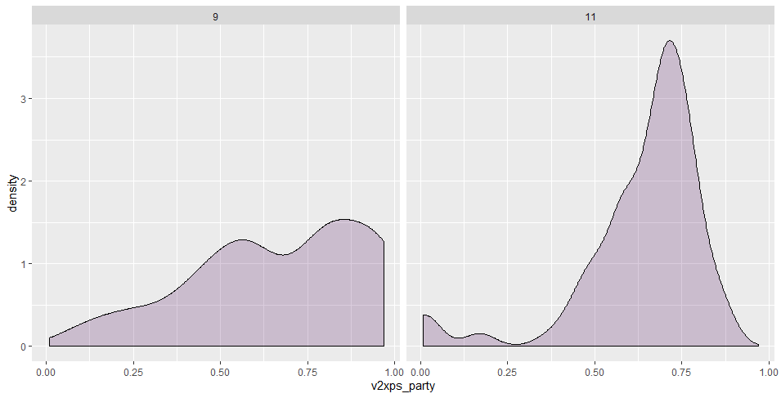

* + 1. Middle classes = Urban + Rural (family farmers)
       - Rather than working classes, middle classes show high levels of internal variations with regards of party institutionalization. → separate?
       - # A tibble: 2 x 4
       - v2regimpgroup mean median sd
       - *<dbl>* *<dbl>* *<dbl>* *<dbl>*
       - 1 10 0.573 0.626 0.227
       - 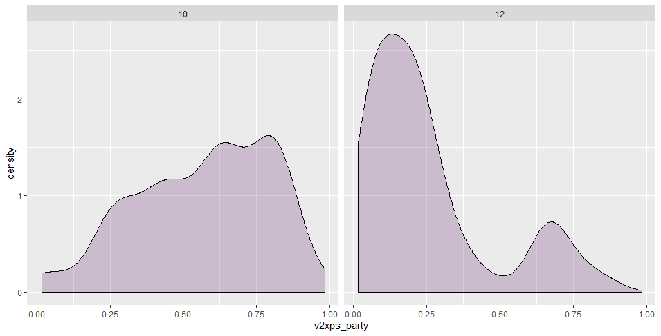2 12 0.251 0.184 0.215
    2. Other groups = The aristocracy + foreign govt or colonial
* > table(autocracies$class_raw)
* Party elites The military The ethnic/racial groups
* 2570 3011 309
* The religous groups Agrarian elites Local elites
* 556 1264 1177
* Business elites Civil servants Urban Working
* 541 641 207
* Rural Working Urban Middle Rural Middle
* 274 348 97
* The aristocracy A foreign govt or colonial
* 2214 736
* **Previous Discussion**
* **Questions**
  + ~~If I want to sample my data limited to authoritarian regime, how to deal with the sample size? (which criteria is good to use? If I use GWF, then my sample would be limited to the time span of GWF (~2010).~~
  + ~~Does the size of supporting group matter? Or “reliable?”~~
  + ~~Figure 1 삭제, Figure 2 ~ 4: Appendix, Figure 5 for plotting indicators by regime type or class-coalition~~
  + ~~Data에서 Authoritarian regime type 은 core supporting group에 관한 내용으로 대체.~~
  + ~~Table 1 살리되 전체 PI 변수 (model 1), models by indicators (5)~~
  + ~~Table 2 에 집중, Table 3는 각각의 변수랑 class 간 interaction을 서로 다른 programs에 대한 연구로. + Show full model.~~
  + The logic of classification of supporting groups.
  + How to organize the section of “Class coalition?”

1. **Walter Institute: Student Scholarship and Grants**

* **Plan**
  + Briefly skimming the existing literature of “Judicialization of politics” to figure out whether it is able to connect the **authoritarian legacies** to **judicialization of politics** in democracies.
  + For the first section: research proposal
    1. Literature reviews (introduction) + Research Question
    2. Case selection and explain how this case-study can help to understand the larger-scale questions.
    3. Simple plan which methods I use and which meterials I use.
  + Describe how I plan to execute my research within the period.
    1. Data collection ← for this, I need to figure out or define how can I conceptualize judicialization of politics.
    2. Methods
    3. Cross-check: through presentation / interview?
  + Brief biographical sketch that describes my credentials in completing this work and how this project fits within my broader research agenda.
* **Time-line: draft complete by Feb 10th.**